
Company
Logotype

Cone Beam Computed Tomography- Report



Porur Dental X-rays & CBCT

Patient Name : Mrs. Aysha Kani | Date of Report : 24.09.2024
Age/ Gender : 58 years/ Female | Region of Interest : CBCT Full Skull
Referring doctor: Dr. S. M. M. Moulvi | Indication : Implant assessment
Clinical Notes: Nil
PATIENT INFORMATION

CBCT- Full Skull provided
CBCT – IMAGE DETAILS

RADIOGRAPHIC INTERPRETATION

- Completely missing crown and root portion in relation to 17, 18, 28, 36, 38, 46, 47, 48.
- In relation to edentulous ridge of 46 region, evidence of a single, irregular, hyperdense region measuring 7.79 x 7.77 x 6.73 mm in dimension, located 5.1 mm from the alveolar ridge and at a distance of 3.1 mm from the apex of 45 is evident.
- Root stumps: 14, 26.

IMPLANT ASSESSMENT

 | 13 region
Sub-Crestal | 8.5
Mid- Crestal | 10.1
Distance between the alveolar ridge and Floor of the Nasal cavity (in mm) | 7.4

 | 16 region | 17 region | 26 region
Sub-Crestal (in mm) | 10.2 | 8.8 | 7.2
Mid- Crestal (in mm) | 10.4 | 11.5 | 12.4
Distance between the alveolar ridge and floor of the maxillary sinus (in mm) | 7.3 | 11.7 | 6.8

 | 36 region | 37 region | 46 region | 47 region
Sub-Crestal (in mm) | 6.6 | 11 | 9.5 | 8.2
Mid- Crestal (in mm) | 10.6 | 12.4 | 11 | 9.5
Distance between alveolar ridge and the inferior alveolar nerve canal (in mm) | 15.9 | 7.8 | 13.9 | 16.4
Distance between alveolar ridge and the inferior border of mandible (in mm) | 24.3 | 19.4 | 25.3 | 25.8

RADIOGRAPHIC IMPRESSION

- Completely edentulous maxillary and mandibular arch.
- Root stumps: 14, 26
- Idiopathic osteosclerosis: 46 region

Kindly correlate with clinical findings


IMAGES FOR REFERENCE

RECONSTRUCTED PANORAMIC VIEW

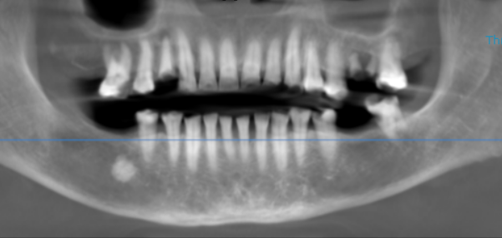

3-DIMENSIONAL VIEW

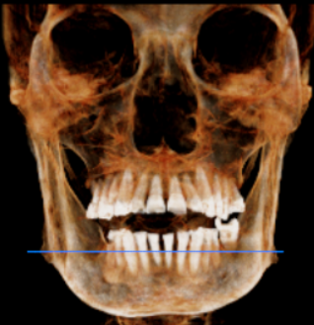

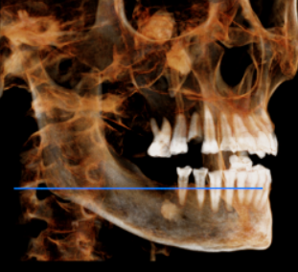
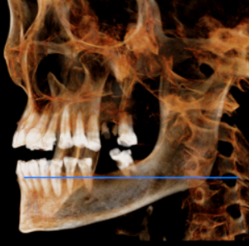

CROSS SECTIONAL VIEW

13 region | 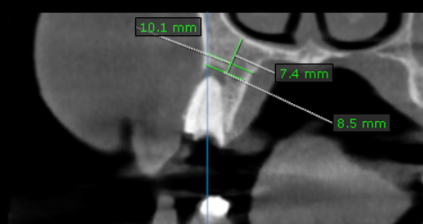
16 region | 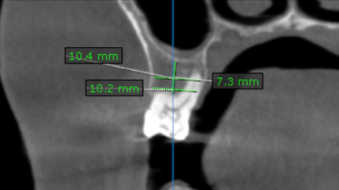
17 region | 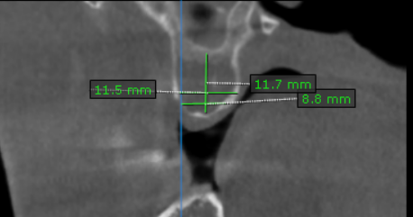
26 region | 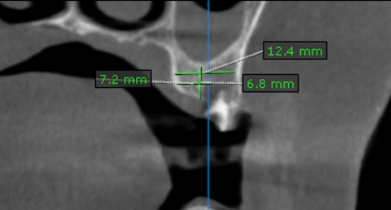
36 region | 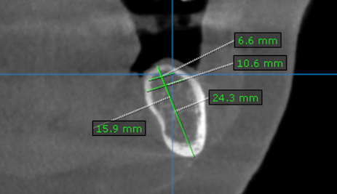
37 region | 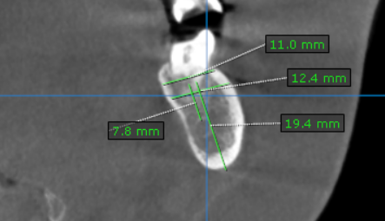
46 region | 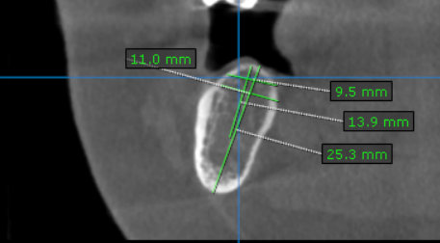
47 region | 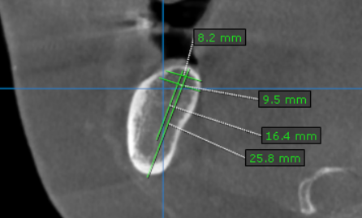

**** End of report ****

